Poultry gas quality Circuit diagram

Lap/Mobile (Processor)

Relay

ESP32

Power Supply

Buzzer

MQ-135 (Gas Sensor)

Exhaust fan

Circuit diagram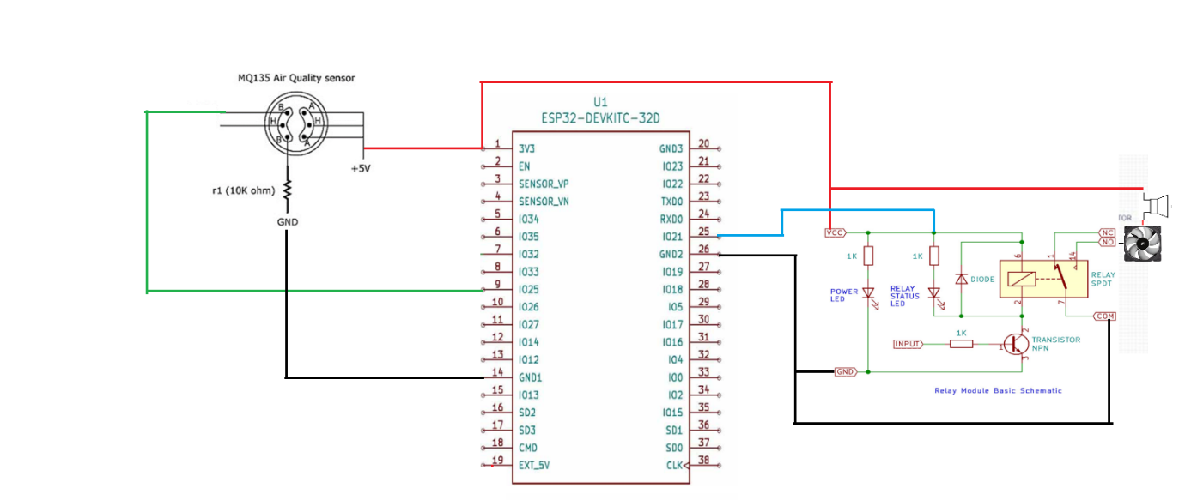

Flow Chart

Start

Input gas sensor value

Read gas sensor value

Gas value > set value

yes No

Buzzer & Fan OFF

Value shown in web page

Buzzer & Fan On